**Online news portal project**

**Chapter 1**

**ABSTRACT:**

The main purpose of the project is intended to develop a portal for management of Web based news. The portal provides a suitable and easy display for which large population around the world can learn or will have the knowledge about the world. Basically this is a crowd sourcing newspaper. The idea is anyone can send a news item using their web based gadget which is managed by administrator to whom the editor’s panel kept in charge for this to make it visible for the masses. This portal is developed using HTML, java & CSS technologies and MYSQL Server.

**INTRODUCTION:**

Software Engineering is the application of systematic, disciplined, and quantifiable approach to the design, development, operation, and maintenance of software, and study of these approaches that is the application of engineering to software. The development of portal for web based newspaper generally means creating a website in which the management of all news item sent by crowd about any type of news & activities are done by the administrator where all people (viewers) can view and know all the relevant information about the knowledge which they seek. This project is about the designing of a newspaper which displays the news which a normal person want to show. This portal is designed by using HTML, java, & CSS technologies and MYSQL Server. The portal has basically three user parts where one is registered user (authentication required) who can view, add comment can have general discussion with another user and another is administrator (has an authentication) who will manage or control the website and other user (no authentication required) can only view and search. The website consists of basic pages from which the user can view and know the relevant information like history, upcoming. In other case, the administrator manages all the relevant actions for which the users can view properly and also make reports.

**PROJECT OBJECTIVE:**

* A role-based system and can be managed like a real newspaper.
* To maintain a standard and structured website.
* To make a website that is updated 24 hours.
* To enhance the quality of news to the users.
* The main objective behind developing this project is to provide a system for the news agencies where they can share the everyday news to their customers.
* Not only this but even the people who love to read/view the news every day can also use this system as here they can read the news as and when they want to read it.
* All they need to do is to log in to the system and then, they can update themselves with the latest updates going on in the world.

**Chapter 2**

**2.1 LITERATURE SURVEY**

A literature survey or a literature review in a project report shows the various analyses and research made in the field of interest and the results already published, taking into account the various parameters of the project and the extent of the project.

A literature survey includes the following

* Existing theories about the topic which are accepted universally.
* Books written on the topic, both generic and specific.
* Research done in the field usually in the order of oldest to latest.
* Challenges being faced and on-going work, if available.

Literature survey describes about the existing work on the given project .It deals with the problem associated with the existing system and also gives user a clear knowledge on how to deal with the existing problems and how to provide solution to the existing problems .different thing.

**OBJECTIVES OF LITERATURE SURVEY**

• Learning the definitions of the concepts.

• Access to latest approaches, methods and theories.

• Discovering research topics based on the existing research

• Concentrate on your own field of expertise– Even if another field uses the same words, they usually mean completely

• It improves the quality of the literature survey to exclude sidetracks– Remember to explicate what is excluded.

We are discussing some related paper:

**[1]Title:** DESIGN OF WEB BASED NEWSPAPER

**Author:** Jayajit Kumar Pradhan, Angela Fogarolli

**Year: 2014**

The development of portal for web based newspaper generally means creating a website in which the management of all news item sent by crowd about any type of news & activities are done by the administrator where all people (viewers) can view and know all the relevant information about the knowledge which they seek. The idea is anyone can send a news item using their web based gadget which is managed by administrator to whom the editor’s panel kept in charge for this to make it visible for the masses. This portal is developed using HTML, PHP & CSS technologies and SQL Server.

**[2]Title:** Enriching a News Portal with Semantic Information: An Entity-Based Approach

**Author:** Stefano Bocconi,

**Year: 2010**

In this paper we describe the production and consumption of linked data in the scenario of the Italian news agency ANSA portal. The goal of the use-case is to provide viewers of a news item with background information and links to related news articles contained on the portal. This information enrichment process is entity-based: ANSA news archive is analyzed using Name Entity Recognition, and each detected entity is annotated with a unique identifier. These identifiers are obtained using the Entity Name Server developed within the scope of the OKKAM European project. Subsequently the news are published on the portal using RDFa and linked to Sig.ma, a semantic search engine that provide background information harvested from sources such as DBpedia and links to additional news sources. The presented project has the potential to contribute to Linked Data by creating and publishing a large quantity of entities and assertions about them coming from the ANSA news archive.

**[3]Title:** A Systematic Review on the Profiling of Digital News Portal for Big Data Veracity

**Author:** Jamila , Iskandar Bin Ishaka , Fatimah Sidia , Lilly Suriani Affendeya , Ali Mamata

**Year: 2015**

Currently, digital news portals have been one of the most important news sources for Internet users. However, the way it is written depends on the direction of the content. One approach to news reporting is through manipulative writing. Such method of writing has created a number of adverse outcomes such as political unrest, slander and negative perception towards the particular organization, personnel, and country. It is important for readers to choose and select news portal that is reporting positively and to neglect portals which practices manipulative writing approach for their own gains or causing negative impact towards the community. The aim of this study is to structure and analyzed the literature related to data veracity research that can be used to the profile of digital news portal. The method that has been used in this paper is to classify and define data veracity; a systematic literature review is a conduct. It includes journal and conference proceedings. The results come out with objectives in data veracity, the structure of research topics, research trends with publications and framework veracity model validated. This paper provides a complete review of literature related to profiling digital news portal in data veracity.

**[4]Title:** News Portal (centraltimes.in)

**Author:** Gopal Sakarkar1, Priyanka Rangari2

**Year: 2019**

Today the world totally relays upon the electronic media to its every day adventure. People have no time to be updated through newspaper or watching or listening the news on television or radios. People today need to be updated on daily basis in this competitive world. Most of the people get the information about the world around through the internet which is fast, accessible, and reliable. The WWW (World Wide Web) is huge, widely distributed, global information service centre for Information services: news, advertisements, consumer information, financial management, education, government, e-commerce etc, hyper-link information, access and usage information. “24 Hours News Portal” is a service introduced to meet the above requirement and to make the people updated about the news, views, reviews, breaking news and latest headlines in different fields also the new inventions around the world.

**CHAPTER 3**

**FEASIBILITY STUDY**

The feasibility of the project is analyzed in this phase and business proposal is put forth with a very common plan for the project and several cost estimates. During system analysis the feasibility study of the proposed method is to be carried out. This is to make sure that the proposed system is not a load to the company. For feasibility analysis, some understanding of the main supplies for the system is essential.

Three key considerations involved in the feasibility analysis are:

* Economic Feasibility
* Technical Feasibility
* Social Feasibility
* Operational Operational

**Economic Feasibility:**

This study is carried out to ensure the economic impact that the method will have on the association. The amount of fund that the company can pour into the investigate and growth of the method is limited. The expenditures must be justified. Thus the developed system as well within the budget and this was achieved because most of the technologies used are generously obtainable. Only the modified goods had to be purchased.

### Technical Feasibility:

This study is carried out to check the technical feasibility, that is, the technical supplies of the method. Any method developed must not have a high exact on the accessible technical assets. This will guide to high stress on the accessible technical resources. This will guide to high stress being placed on the customer. The developed method must have a modest obligation, as only minimum or null changes are required for implementing this method.

**Social Feasibility:**

The aspect of study is to ensure the level of approval of the method by the user. This includes the process of training the user to utilize the method proficiently. The user necessity not feel threatened by the method, instead must accept it as a essential. The level of acceptance by the users solely depends on the methods that are employed to instruct the user about the method and to make him recognizable with it. His level of assurance must be raised so that he is also able to make some productive appreciation, which is welcomed, as he is the finishing user of the method.

**Operational Operational**

Define the urgency of the problem and the acceptability of any solution; if the system is developed, will it be used? Includes peopleoriented and social issues: internal issues, such as manpower problems, labour objections, manager resistance, organizational conflicts and policies; also external issues, including legal aspects and government regulations, also social acceptability of the new system.

**CHAPTER 4**

**SYSTEM REQUIREMENTS SPECIFICATION**

**4.1 REQUIREMENT SPECIFICATION:**

Framework Requirement Specification (SRS) is a focal report, which outlines the foundation of the item headway handle. It records the necessities of a structure and in addition has a delineation of its noteworthy highlight. A SRS is basically an affiliation's seeing (in making) of a customer or potential client's edge work necessities and conditions at a particular point in time (for the most part) before any veritable design or change work. It's a two-way insurance approach that ensures that both the client and the affiliation understand exchange's necessities from that perspective at a given point in time.

The synthesis of programming need detail reduces headway effort, as careful review of the report can reveal oversights, mixed up presumptions, and inconsistencies in front of plan for the change cycle when these issues are less requesting to right. The SRS discusses the thing however not the wander that made it, thusly the SRS fills in as a start for later change of the finished thing.

The SRS may should be changed, be that as it may it gives a foundation to continue with creation appraisal. In direct words, programming need assurance is the starting phase of the item change activity. The SRS implies unraveling the musings in the brains of the clients – the data, into a formal chronicle – the yield of the essential stage. In this manner the yield of the stage is an arranged of formally decided necessities, which in a perfect world are done and relentless, while the information has none of these properties.

4.1.1 HARDWARE REQUIREMENTS

System : Intel i3 2.1 GHZ

Memory : 4GB.

Hard Disk : 40 GB

4.1.2 SOFTWARE REQUIREMENTS

Operating System : Windows 7 / 8.

Language : JAVA, HTML, CSS

Tool : NetBeans, navicat lite for mysql

Database : MySQL

Local Server : Apache Tomcat

**4.2 SOFTWARE DESCRIPTION**

**4.2.1 NET BEANS IDE**

Net Beans IDE is the official IDE for Java 8. With its editors, code analyzers, and converters, you can quickly and smoothly upgrade your applications to use new Java 8 language constructs, such as lambdas, functional operations, and method references. Batch analyzers and converters are provided to search through multiple applications at the same time, matching patterns for conversion to new Java 8 language constructs. With its constantly improving Java Editor, many rich features and an extensive range of tools, templates and samples, NetBeans IDE sets the standard for developing with cutting edge technologies out of the box. An IDE is much more than a text editor. The NetBeans Editor Indent lines, matches words and brackets, and highlight source code syntactically and semantically. It also provides code templates, coding tips, and refactoring tools. The editor supports many languages from Java, C/C++, XML and HTML, to PHP, Groovy, Javadoc, JavaScript and JSP. Because the editor is extensible, you can plug in support for many other languages. Keeping a clear overview of large applications, with thousands of folders and files, and millions of lines of code, is a daunting task. NetBeans IDE provides different views of your data, from multiple project windows to helpful tools for setting up your applications and managing them efficiently, letting you drill down into your data quickly and easily, while giving you versioning tools via Subversion, Mercurial, and Get integration out of the box. When new developers join your project, they can understand the structure of your application because your code is well-organized.

Design GUIs for Java SE, HTML5, Java EE, PHP, C/C++, and Java ME applications quickly and smoothly by using editors and drag-and-drop tools in the IDE. For Java SE applications, the NetBeans GUI Builder automatically takes care of correct spacing and alignment, while supporting in-place editing, as well. The GUI builder is so easy to use and intuitive that it has been used to prototype GUIs live at customer presentations. The cost of buggy code increases the longer it remains unfixed. NetBeans provide static analysis tools, especially integration with the widely used FindBugs tool, for identifying and fixing common problems in Java code. In addition, the NetBeans Debugger lets you place breakpoints in your source code, add field watches, step through your code, run into methods. The NetBeans Profiler provides expert assistance for optimizing your application's speed and memory usage, and makes it easier to build reliable and scalable Java SE, JavaFX and Java EE applications. NetBeans IDE includes a visual debugger for Java SE applications, letting you debug user interfaces without looking into source code. Take GUI snapshots of your applications and click on user interface elements to jump back into the related source code.

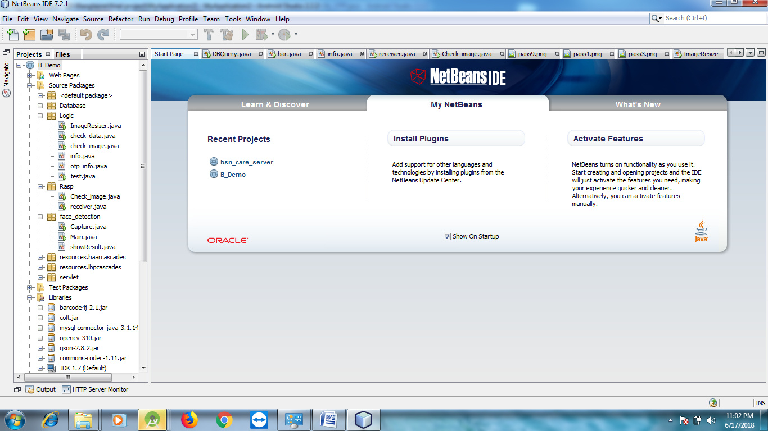

Fig: Snap Shot of Net Beans

**4.2.2 MySQL**

MySQL ("My Sequel") is (as of 2008) the world's most widely used open source relational database management system (RDBMS) that runs as a server providing multi-user access to a number of databases. The SQL phrase stands for Structured Query Language.

The MySQL development project has made its source code available under the terms of the GNU General Public License, as well as under a variety of proprietary agreements. MySQL was owned and sponsored by a single for-profit firm, the Swedish company MySQL AB, now owned by Oracle Corporation.

MySQL is a popular choice of database for use in web applications, and is a central component of the widely used LAMP open source web application software stack (and other 'AMP' stacks). LAMP is an acronym for "Linux, Apache, MySQL, Perl/PHP/Python." Free-software-open source projects that require a full-featured database management system often use MySQL.

MySQL is a relational database management system (RDBMS), and ships with no GUI tools to administer MySQL databases or manage data contained within the databases. Users may use the included command line tools, or use MySQL "front-ends", desktop software and web applications that create and manage MySQL databases, build database structures, back up data, inspect status, and work with data records. The official set of MySQL front-end tools, MySQL Workbench is actively developed by Oracle, and is freely available for use.

MySQL, like most other transactional relational databases, is strongly limited by hard disk performance. This is especially true in terms of write latency. Given the recent appearance of very affordable consumer grade SATA interface Solid-state drives that offer zero mechanical latency, a fivefold speedup over even an eight drive RAID array can be had for a smaller investment.

**4.2.3 NAVICAT PREMIUM**

Navicat Premium is a multi-connections database administration tool allowing you to connect to MySQL, Maria DB, SQL Server, and SQLite, Oracle and PostgreSQL databases simultaneously within a single application, making database administration to multiple kinds of database so easy. Navicat Premium combines the functions of other Navicat members and supports most of the features in MySQL, MariaDB, SQL Server, SQLite, Oracle and PostgreSQL including Stored Procedure, Event, Trigger, Function, View, etc.

Navicat Premium enables you to easily and quickly transfer data across various database systems, or to a plain text file with the designated SQL format and encoding. Also, batch job for different kind of databases can also be scheduled and run at a specific time. Other features include Import/ Export Wizard, Query Builder, Report Builder, Data Synchronization, Backup, Job Scheduler and more. Features in Navicat are sophisticated enough to provide professional developers for all their specific needs, yet easy to learn for users who are new to database server.

Establish a secure SSH session through SSH Tunneling in Navicat. You can enjoy a strong authentication and secure encrypted communications between two hosts. The authentication method can use a password or public / private key pair. And, Navicat comes with HTTP Tunneling while your ISPs do not allow direct connections to their database servers but allow establishing HTTP connections. HTTP Tunneling is a method for connecting to a server that uses the same protocol (http://) and the same port (port 80) as a webserver does.

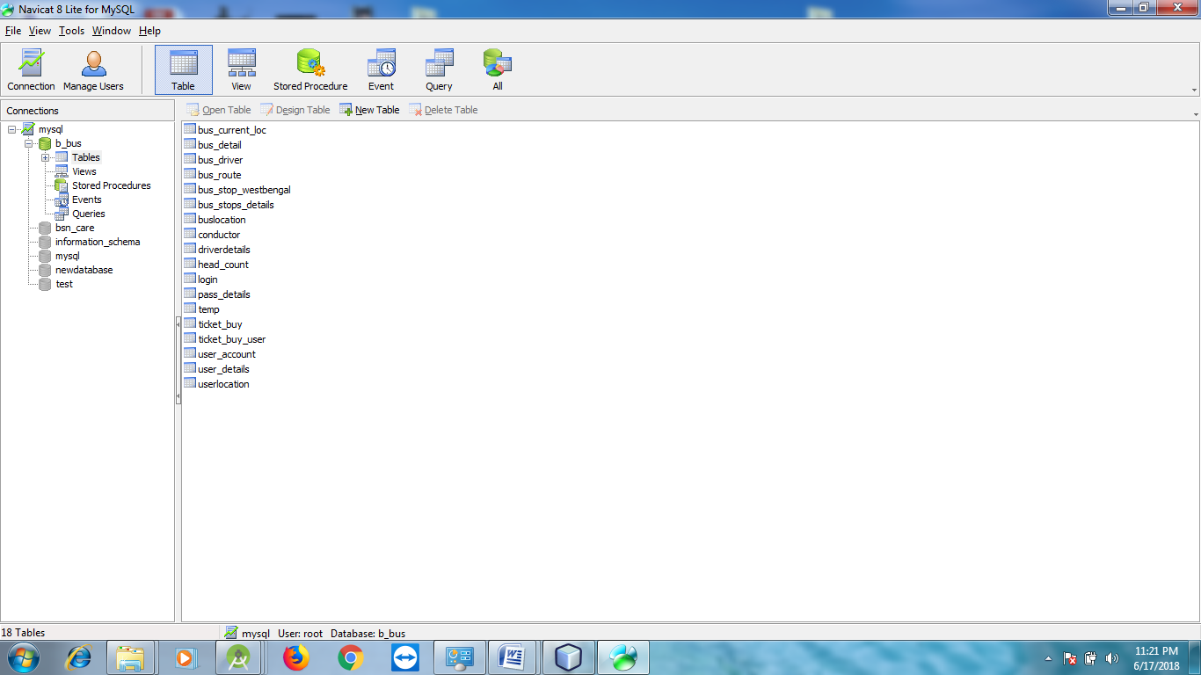

Navicat Lite for MySQL

**4.3Technologies used**

**4.3.1 The Java Programming Language**

It is a phase free programming lingo that extends its parts wide over the framework. Java2 interpretation introduces another parts than are possible with AWT

* It's a light weight package, as they are not executed by stage specific code.
* Related classes are contained in javax.swing and its sub groups, for instance, javax.swing.tree
* Components illuminated in the swing have a bigger number of limits than those of AWT.

Java byte codes are the stage free codes interpreted by the interpreter on the Java arrange. The go between parses and runs each Java byte code rule on the PC. Gathering happens just once; understanding happens each time the program is executed. The going with figure demonstrates how this capacities.

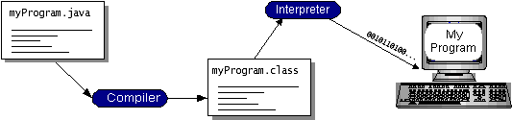

**Figure: Java Programming Language Execution**

We can consider Java byte codes as the machine code headings for the Java Virtual Machine arrange that has a Java compiler. The byte codes can then be continue running on any use of the Java VM. That infers that the length of a PC has a Java VM, a comparative program written in the Java programming lingo can continue running on Windows 2000, a Solaris workstation, or on an iMac.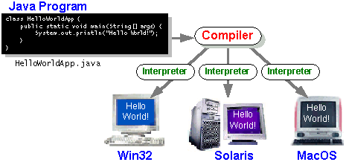

**Figure: Sample program execution**

**4.3.2 HTML**

Hypertext Markup Language (HTML) is the standard markup lingo for making site pages and web applications. With Cascading Style Sheets (CSS) and JavaScript it shapes a gathering of three of establishment headways for the World Wide Web.[1] Web programs get HTML files from a webserver or from neighborhood stockpiling and render them into sight and sound site pages. HTML delineates the structure of a site page semantically and at first included signs for the nearness of the chronicle.

HTML parts are the building squares of HTML pages. With HTML creates, pictures and distinctive things, for instance, astute structures, may be introduced into the rendered page. It gives an approach to make sorted out records by connoting helper semantics for substance, for instance, headings, sections, records, associations, refers to and distinctive things. HTML segments are depicted by names, made using point segments. Names, for instance, <img/> and <input/> bring content into the page particularly. Others, for instance, <p>...</p> envelop and give information about report message and may consolidate distinctive marks as sub-segments. Projects don't demonstrate the HTML names, however use them to interpret the substance of the page.

**4.3.3 CSS**

CSS is designed primarily to enable the separation of document content from document presentation, including aspects such as the layout, colors, and fonts. This separation can improve content accessibility, provide more flexibility and control in the specification of presentation characteristics, enable multiple HTML pages to share formatting by specifying the relevant CSS in a separate .css file, and reduce complexity and repetition in the structural content.

**4.3.4 Java script**

JAVA SCRIPT JavaScript is a lightweight, interpreted programming language. It is designed for creating network-centric applications. It is complimentary to and integrated with Java. JavaScript is very easy to implement because it is integrated with HTML. It is open and cross-platform.

**4.4 Apache Tomcat Server 7.0**

Apache Tomcat, routinely insinuated as Tomcat Server, is an open-source Java Servlet Container made by the Apache Software Foundation (ASF). Tomcat executes a couple Java EE points of interest including Java Servlet, Java Server Pages (JSP), Java EL, and Web Socket, and gives a "flawless Java" HTTP web server condition in which Java code can run.

Tomcat is made and kept up by an open gathering of specialists under the support of the Apache Software Foundation, released under the Apache License 2.0 allow, and is open-source programming.

**4.6 FUNCTIONAL REQUIREMENT**

For documenting the functional requirements, the set of functionalities supported by the system are to be specified. A function can be specified by identifying the state at which the data is to be input to the system, its input data domain, the output data domain, and the type of processing to be carried on the input data to obtain the output data. Basically the management parts are the functional requirements which are uploading details, search topic, edit option and user registration.

* Reporter can register
* Reporter can login
* Reporter is able to upload news details
* User can register
* User can login
* User is able to read news

**4.7 NON-FUNCTIONAL REQUIREMENT**

* **Usability**

The client acknowledge be typical nearly the buyer interfaces and committed to ask for ambush pressure in relocating to a unique framework with another condition.

* **Reliability**

The progressions made by the Programmer ought to be obvious both to the Project pioneer and in addition the Test design.

* **Security**

Counting bug following the framework must give important security and must secure the entire procedure from slamming.

* **Performance**

The framework will be facilitated on a solitary web server with a solitary database server out of sight, consequently execution turns into a noteworthy concern.

* **Portability**

This is required when the web server, which is facilitating the framework stalls out because of a few issues, which requires their framework to be taken to another framework.

* **Reusability**

The framework ought to be separated into such modules that it could be utilized as a piece of another framework without requiring a lot of work.3.6 Technologies used.

**CHAPTER 5**

**SYSTEM ANALYSIS**

**EXISTING SYSTEM:**

In the existing scenario, if a person wants to get some news about the world or what is going on around him/her, then he /she needs to go through the newspaper. It is a very long process. First to buy the newspaper and then to go through every page of the paper. If someone is looking for some specific sector news, then it got tough for them to get the news directly.

**Disadvantages:**

* It can be limited by time
* Manual process

**PROPOSED SYSTEM:**

In the proposed system of java, while going through the application, the reader can directly login into the system and he/she can choose the domain of news, which they are looking for and can read it. Though, it is also not needed to buy the newspaper. They can read it online. Also, every update/news will come to them directly. The updates will appear to their feeds automatically.

**Advantages:**

* We develop this project that helps the people and make them aware so that they can know any news.
* To establish this website, we use various methodologies.
* Our supervisor helps us by giving his valuable opinion, decision and time.

**CHAPTER 6**

**SYSTEM DESIGN**

**6.1 Introduction**

The framework configuration prepare develops general structure building outline. Programming diagram incorporates addressing the item system works in a shape that might be changed into at least one anticipates. The essential demonstrated by the end customer must be placed in a systematical way. Diagram is a creative system; an extraordinary design is the best approach to reasonable structure. The structure "Layout" is portrayed as "The methodology of applying distinctive frameworks and guidelines with the ultimate objective of describing a strategy or a system in sufficient purpose important to permit its physical affirmation". Diverse design segments are taken after to add to the system. The design detail depicts the segments of the system, the sections or segments of the structure and their appearance to end-customers.

**6.2 Design Consideration**

The explanation behind the plan is to orchestrate the course of action of the issue dictated by the necessities report. This stage is the underlying stage in moving from issue to the game plan space. All things considered, start with what is obliged; diagram takes us to work towards how to satisfy those necessities. The design of the system is perhaps the most essential segment affecting the way of the item and note worthily affects the later stages, particularly testing and upkeep. System diagram delineates all the huge data structure, report game plan, yield and genuine modules in the system and their Specification is picked.

**6.3 SYSTEM ARCHITECTURE**

The architectural configuration procedure is concerned with building up a fundamental basic system for a framework. It includes recognizing the real parts of the framework and interchanges between these segments. The beginning configuration procedure of recognizing these subsystems and building up a structure for subsystem control and correspondence is called construction modeling outline and the yield of this outline procedure is a portrayal of the product structural planning. The proposed architecture for this system is given below. It shows the way this system is designed and brief working of the system.

Server

Upload news

Reporter

Read news

User

**6.4 Data Flow Diagrams**

The DFD is clear graphical formalism that can be used to address a structure the extent that the data to the system, diverse get ready did on this data and the yield data made by the structure. A DFD demonstrate utilizes an incredibly foreordained number of primitive pictures to address the limits performed by a system and the data stream among the limits.

The standard inspiration driving why the DFD strategy is so celebrated is probably in light of the way that DFD is an uncommonly essential formalism-It is anything but difficult to fathom and use. Starting with the course of action of strange state works that a system plays out, a DFD show dynamically addresses diverse sub limits. Really, any different leveled model is anything but difficult to get it.

The human identity is to such an extent that it can without quite a bit of an extend see any dynamic model of a structure in light of the way that in a different leveled display, starting with a to a great degree clear and extraordinary model of system, unmistakable purposes of enthusiasm of a structure are bit by bit introduced through the various requests. An information stream outline (DFD) is a graphical portrayal of the "stream" of data through an information structure. DFDs can in like manner be used for the view of data taking care of.

**DFD Components**

DFD can represent Source, destination, storage and flow of data using the following set of components -

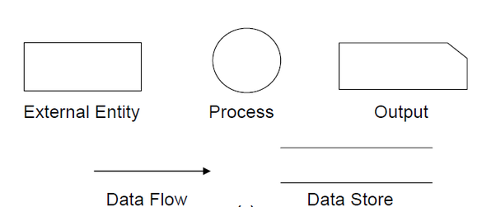

**Entities** - Entities are source and destination of information data. Entities are represented by rectangles with their respective names.

**Process** - Activities and action taken on the data are represented by Circle or Round edged rectangles.

**Data Storage** - There are two variants of data storage - it can either be represented as a rectangle with absence of both smaller sides or as an open-sided rectangle with only one side missing.

**Data Flow** - Movement of data is shown by pointed arrows. Data movement is shown from the base of arrow as its source towards head of the arrow as destination.

**DFD-L0:**

Browser

Id , pw

Reporter

**DFD-L1:**

Image, file

View details

Into

Server

Reporter

Fetch from server

**DFD-L2:**

Access web

Web application

Id, pw

User

Server

Fetch

**6.5 Use Case Diagram**

A use case chart is a kind of behavioral graph made from a Use-case examination. Its object is to present a graphical diagram of the usefulness gave by a framework regarding performers, their objectives (spoke to as utilization cases), and any conditions between those utilization cases. Use case chart gives us the data about how that clients and utilization cases are connected with the framework. Use cases are used amid prerequisites elicitation and examination to speak to the usefulness of the framework. Use cases concentrate on the conduct of the framework from an outside perspective.

A use case depicts a capacity gave by framework that yields an obvious result for a performer. A performing artist portrays any element that collaborates with the system. The performers are outside the limit of the framework, while the use cases are inside the limit of the framework. On-screen characters are spoken to with stick figures, use cases with ovals, and the limit of the framework with a container encasing the use cases.

Reporter

User

**6.6 Sequence diagram:**

A sequence diagram is a system is an interaction diagram that shows how process operates with one and other and in what order. It’s a construct of a message sequence chart. A sequence diagram shows object interactions arranged in time sequence. It depicts the objects and classes involved in the scenario and sequence of messages exchange between the objects needed to carry out the functionality of the scenario. Sequence diagram are sometimes called event diagrams or event scenarios.

Login

User

Server

Reporter

Publish news

Upload file

Register

Login

Read news

**6.6 ER diagram:**

Add

News details

reporter

Upload

Image

**6.6 Activity diagram:**

Start

View report

Read news

Upload image/video

Publish news detail

Register login

Reporter register

End

**CHAPTER 7**

**SYSTEM IMPLEMENTATION**

**7.1 Introduction**

This stage is the underlying stage in moving from issue to the course of action space. Accordingly, starting with what is obliged; diagram takes us to work towards how to full fill those requirements. System plot portrays all the critical data structure, record course of action, yield and genuine modules in the structure and their Specification is picked. This assumes an essential part on the grounds that as it will give the last yield on which it was being working.

**7.2 MODULES OF THE PROJECT:**

In our work we are using three modules, these modules are listed below

**1. User panel**

The user panel is that panel which is accessed by the readers of this system. Via this panel, a user can log in into the system and check the news as per his/her choice. This panel is only for the readers. They have to login into the system and they will be able to read the news. They will also ask for the options which will say what the most read topics are or subjects in which the user is interested in.

**2. Reporter panel**

Reporter module is for the reporters of the system. They are the people who update the news for their readers. They login from the backend and update the daily news. They can restrict the viewers for particular news too. They can choose who can view the news and who cannot. Sometimes, they can also restrict the users too.

**3. News feed module**

All the news by the Reporter is updated into this module. This news has many sections and each section is specific to a particular domain. reporter can update the news into this panel and thus viewers and readers can read the news from their feed.

**Screen shot of web application:**

1. **Login and sign up Page:**

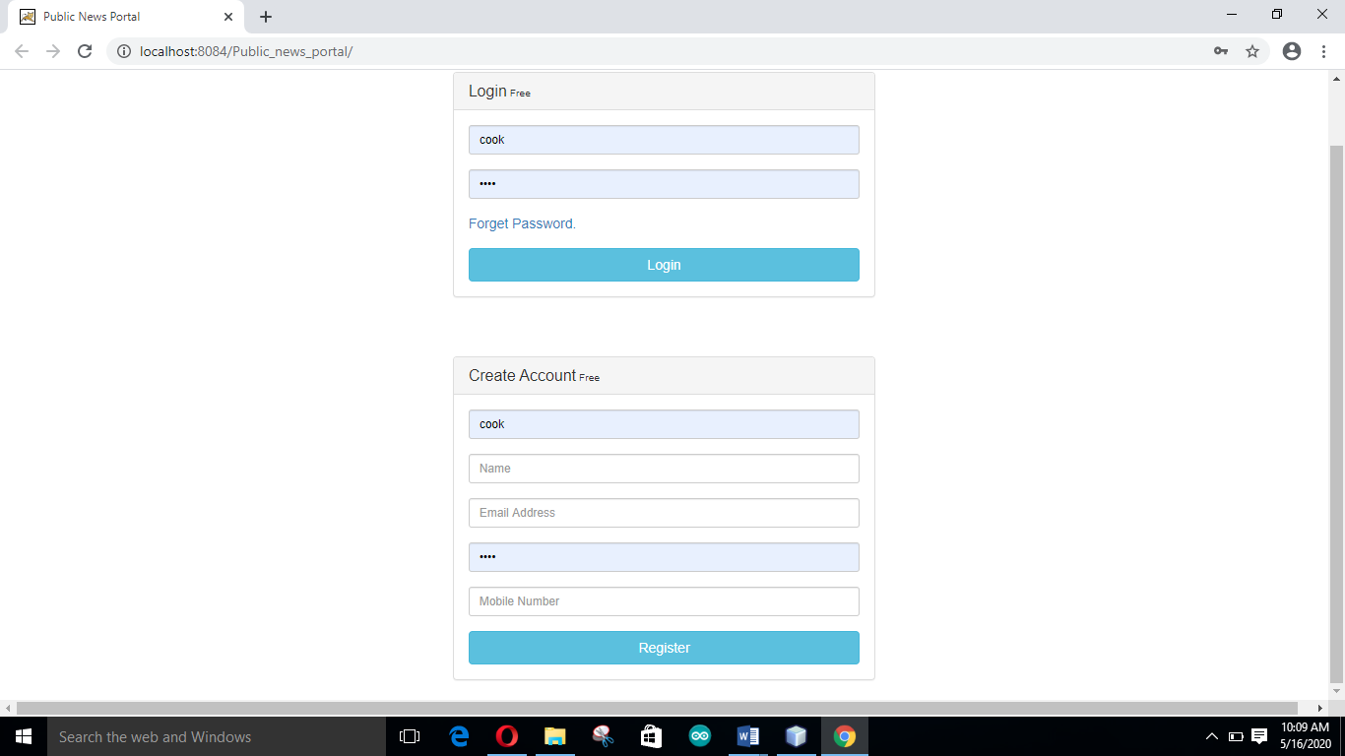

1. **Reporter home Page:**

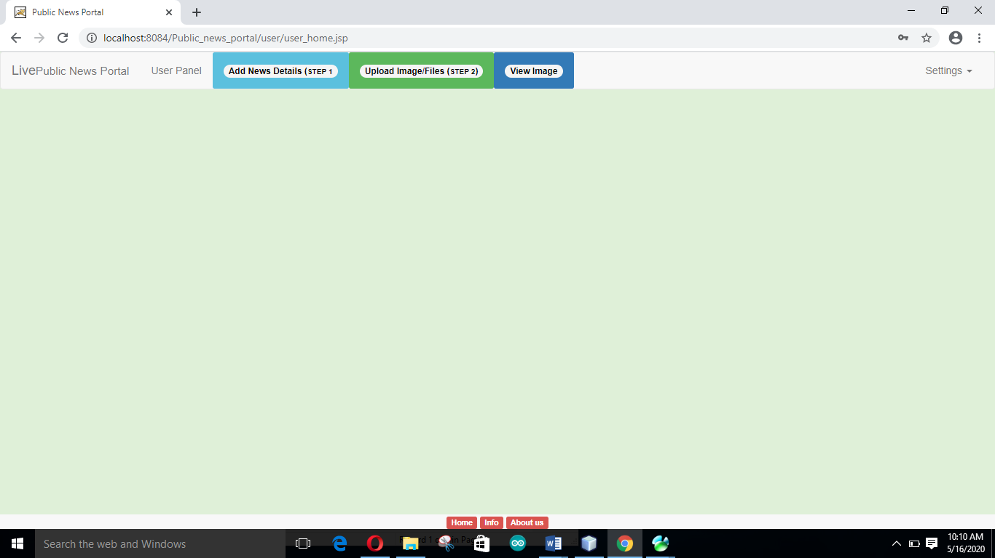

1. **Add news details Page:**

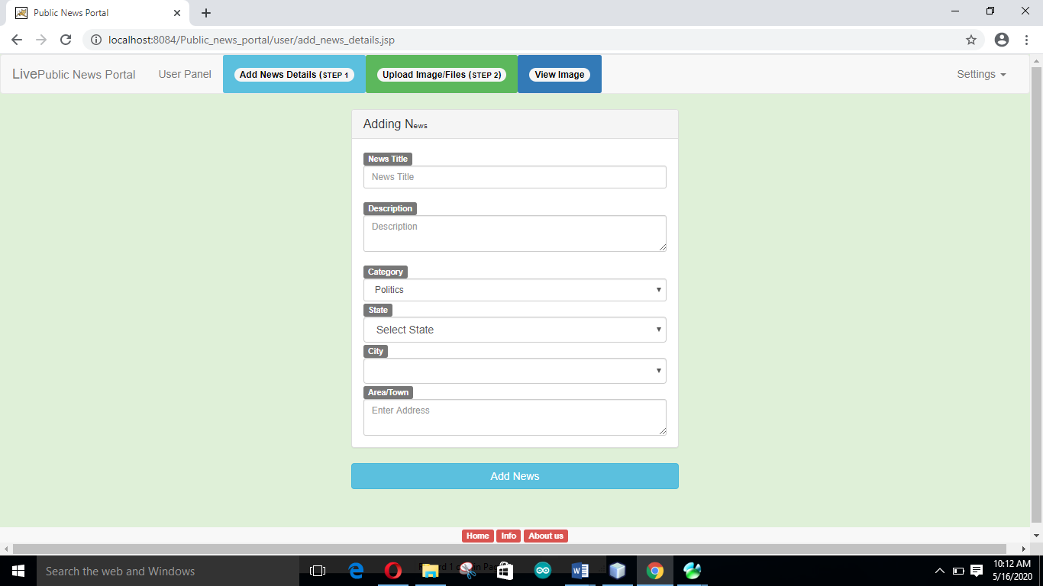

1. **News added message Page**

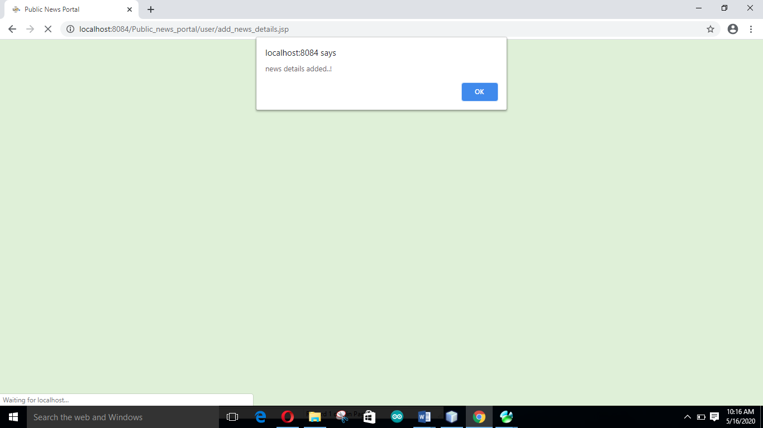

1. **Upload file Page**

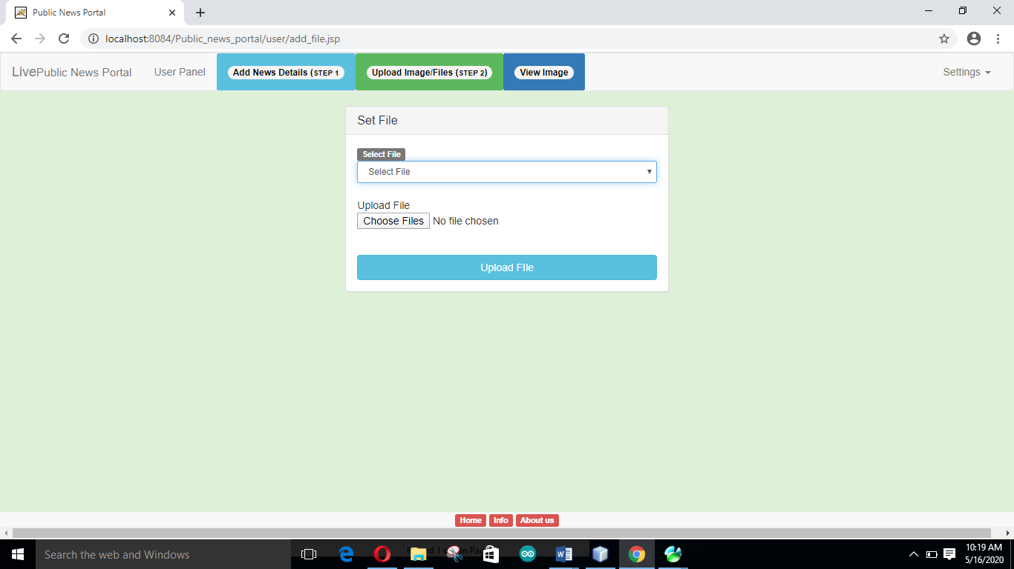

1. **View image or video Page**

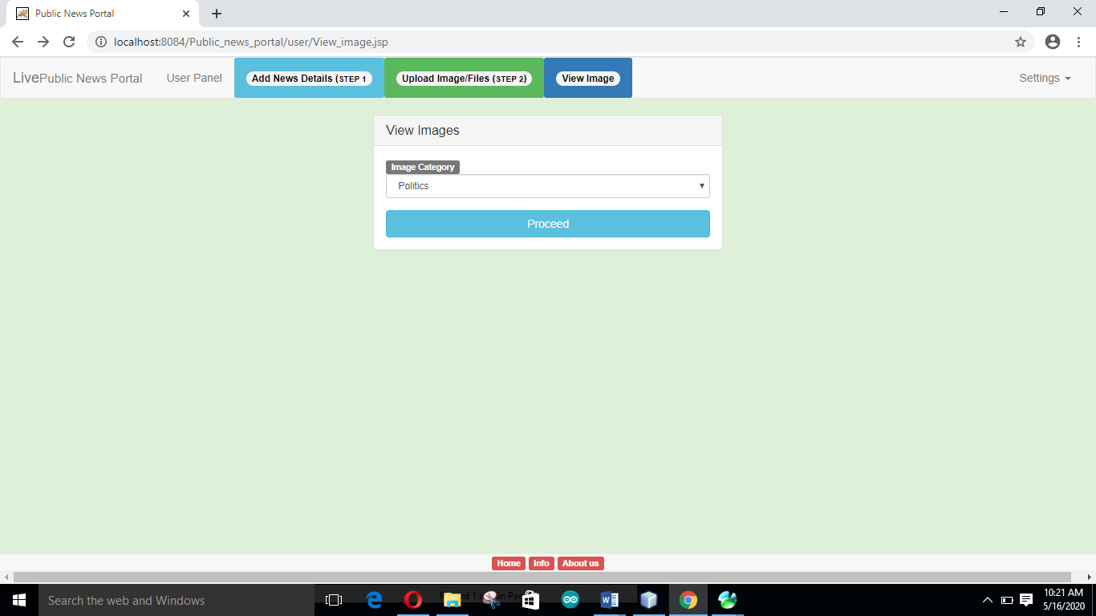

**Chapter 8**

**SYSTEM TESTING**

**8.1 Introduction**

Testing of any product comprise of giving the product an arrangement of test information and watching if the product carries on not surprisingly, if the product neglects to carry on obviously ,then the conditions under which of disappointment happens are noted for investigating and amendment. At last the framework in general is tried to guarantee that blunder in past countenances are revealed and the venture acts as determined.

**8.2 Basics of software testing:**

**8.2.1 Black Box testing**

Black box testing is done to find the following

* + Incorrect or missing functions
  + Interface errors
  + Errors on external database access
  + Performance error
  + Initialization and termination error

**8.2.2 White Box Testing**

This allows the tests to

* Check whether all independent paths within a module have been exercised at least once
* Exercise all logical decisions on their false sides
* Execute all loops and their boundaries and within their boundaries
* Exercise the internal data structure to ensure their validity
* Ensure whether all possible validity checks and validity lookups have been provided to validate data entry.

**8.3 Types of Testing**

Following are the different types of testing

* Unit Testing
* Integration Testing
* System Testing
* Performance Testing
* Validation Testing
* Acceptance Testing

Let us consider each testing and discuss on it in detail. Firstly we move to the first testing and give its detail description.

**8.3.1 Unit Testing**

Singular part are tried to guarantee that they work accurately. Every part is tried freely, without other framework segment. This framework was tried with the arrangement of legitimate test information for every module and the outcomes were checked with the normal yield. Unit testing centers around confirmation exertion on the littlest unit of the product outline module. This is otherwise called MODULE TESTING. This testing is done amid stages, every module is observed to work agreeable as respects to the normal yield from the module.

**8.3.2 Integration Testing**

Mix testing is another part of testing that is for the most part done keeping in mind the end goal to reveal mistakes related with stream of information crosswise over interfaces. The unit-tried modules are assembled together and tried in little section, which make it less demanding to seclude and revise mistakes. This approach is proceeded with unit I have coordinated all modules to frame the framework all in all.

**8.3.3 System Testing**

Framework testing is really a progression of various tests whose basic role is to completely practice the PC based framework. Framework testing guarantees that the whole incorporated programming framework meets prerequisites. It tests a design to guarantee known and unsurprising outcomes. A case of framework testing is the setup arranged framework mix testing. Framework testing depends on process depiction and streams, underscoring pre-driver process and incorporation focuses.

**8.3.4 Performance Testing**

The execution testing guarantee that the yield being delivered inside as far as possible and time taken for the framework aggregating, offering reaction to the clients and demand being send to the framework so as to recover the outcomes.

**8.3.5 Validation Testing**

The approval testing can be characterized from multiple points of view, however a straightforward definition is that. Approval succeeds when the product capacities in a way that can be sensibly expected by the end client.

**8.3.6 Acceptance Testing**

This is the last phase of testing procedure before the framework is acknowledged for operational utilize. The framework is tried inside the information provided from the framework procurer instead of recreated information.

**Table 1 Unit Test Case 1**

|  |  |
| --- | --- |
| S1 # 3Test 3Case | UTC-*1 |
| Name3of3Test | Index page |
| Expected3Result | Index is a first page. Reporter can get login and register option |
| Actual3output | Same3as3expected. |
| Remarks3 | Successful |

**Table 2 Unit Test Case 2**

|  |  |
| --- | --- |
| S2 # 3Test 3Case | UTC-*2 |
| Name3of3Test | Registration page |
| Expected3Result | Reporter can register from web application. When reporter will register then each input field will check the validation. |
| Actual3output | Same3as3expected. |
| Remarks3 | Successful |

**Table 3 Unit Test Case 3**

|  |  |
| --- | --- |
| S3 # 3Test 3Case | UTC-*3 |
| Name3of3Test | Login page |
| Expected3Result | User can login. Checks if id and password are valid or not. |
| Actual3output | Same3as3expected. |
| Remarks3 | Successful |

**Table 4 Unit Test Case 4**

|  |  |
| --- | --- |
| S4 # 3Test 3Case | UTC-*4 |
| Name3of3Test | Publish news |
| Expected3Result | Reporter can publish news details with image or video. |
| Actual3output | Same3as3expected. |
| Remarks3 | Successful |

**Table 5 Unit Test Case 5**

|  |  |
| --- | --- |
| S5 # 3Test 3Case | UTC-*5 |
| Name3of3Test | View news details |
| Expected3Result | After publishing news, reporter can view news details. |
| Actual3output | Same3as3expected. |
| Remarks3 | Successful |

|  |  |
| --- | --- |
| S6 # 3Test 3Case | UTC-*6 |
| Name3of3Test | Read news |
| Expected3Result | User can select category of news and they can read the news. |
| Actual3output | Same3as3expected. |
| Remarks3 | Successful |

**CONCLUSION:** It is a very cost-effective and time-saving news reading system. One does not need to go away to buy the newspaper. He/she can read the news relevant to his/her choice at a single click and in a very little time stamp.

**REFERENCES:**

1. Fundamentals of Software Engineering, Rajiv Mall, New Delhi: PHI Learning limited, 2003

2. Paul Nielsen, SQL Server 2005 Bible. Paul Nielsen, New Delhi: Wiley, 2006

3. HTML, and CSS Bible. Bill Karow, Chuck White, Steven M. Schafer Bryan Pfaffenberger, New York: Wiley 2004

4. http://en.wikipedia.org/wiki/Software_engineering

5. http://www.w3schools.com/html/html_intro.asp